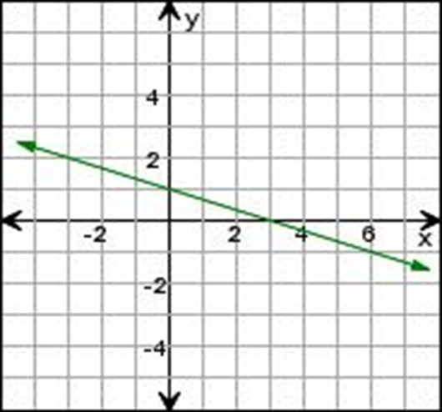  Slope: Positive or Negative  Slope (m): _________________  Y-Intercept (b): _____________  $$y=______________________________$$ | 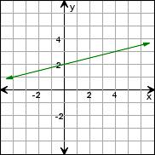  Slope: Positive or Negative  Slope (m): _________________  Y-Intercept (b): _____________  $$y=______________________________$$
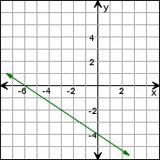  Slope: Positive or Negative  Slope (m): _________________  Y-Intercept (b): _____________  $$y=______________________________$$ | 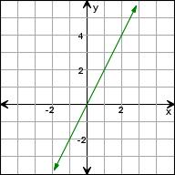  Slope: Positive or Negative  Slope (m): _________________  Y-Intercept (b): _____________  $$y=______________________________$$
Hey, students! Go to student.desmos.com and type in:
Writing Equations from Lines of Best Fit
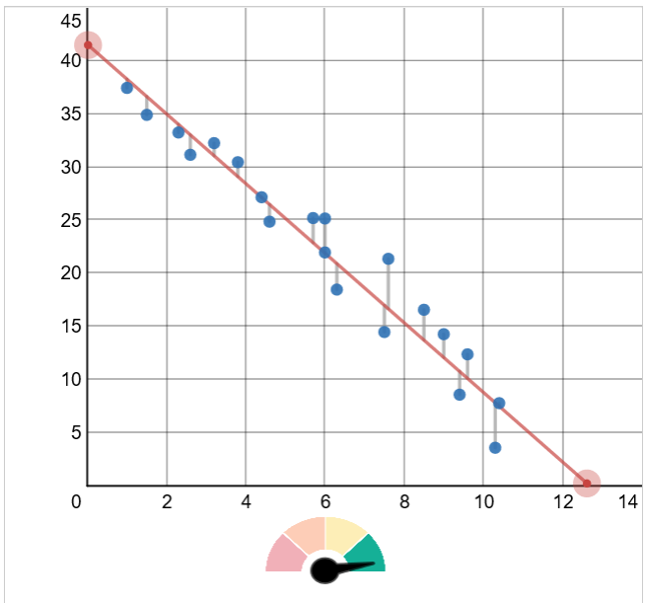  Slope: Positive or Negative  Slope (m): _________________  Y-Intercept (b): _____________  $y=$_______________________ | 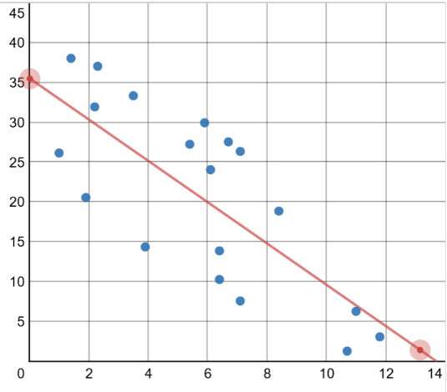  Slope: Positive or Negative  Slope (m): _________________  Y-Intercept (b): _____________  $y=$_______________________
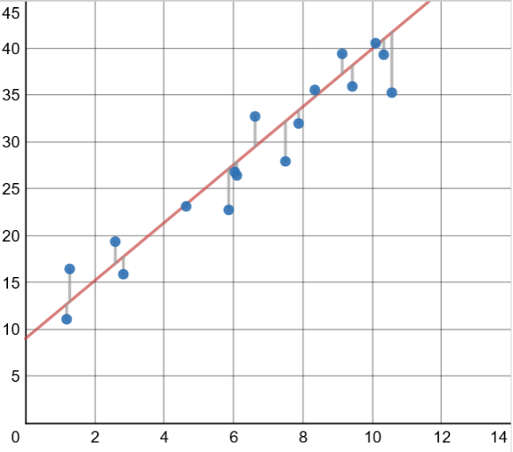

Write an equation for the line of best fit.

